**Good and bad plots: Comparing graphs on the same topic 105 years apart**

Graphs have had a long history of use in academia to summarize data via visual representation to improve understanding and impact of the results. I selected two graphs that attempt to describe the effect of dazzle camouflage over 105 years apart. Dazzle camouflage is a combination of zig-zag, blob and random-shaped patterns of high-contact colours that were applied to ships in WW1 to confuse the enemy to the ship's location when attacking it with torpedoes (Meese & Strong, 2024).

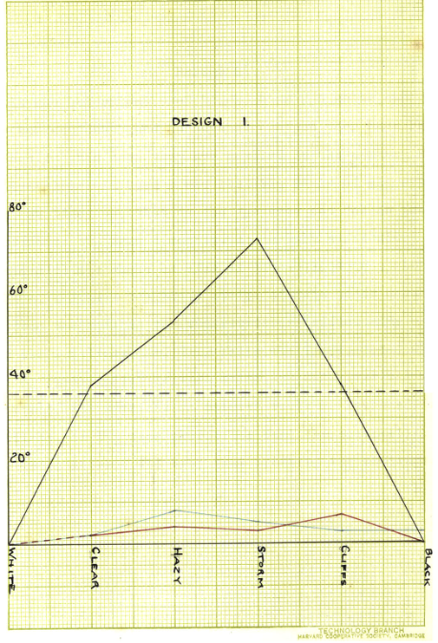Figure 1. The bad graph taken from Blodgett (1919)

The original study explored the effect of dazzle camouflage under different environmental conditions and was completed by Blodgett in 1919. The study has major design, methodology, and data analysis issues, including a lack of detail, missing information, and incorrect calculations (Meese & Strong, 2024). As expected, the graphs included in this paper are poorly designed and difficult to understand, see Figure 1. One of the most glaring issues is the lack of axis titles, but along the y-axis, the units used are present. The category names are vertically oriented for the x-axis, making it more difficult to read than if they were horizontally oriented. The spacing along the x-axis would have been large enough to accommodate the horizontal text. The black, blue, and red coloured lines denote different colour patterns of the ship; dazzle camouflage, black, and blue, respectively, are not directly labelled or have a legend on the graph. The description of the graph is located on a separate page, requiring greater time and effort to identify the colour's meaning, and some of the colour choices for the line are the same colour used for the ship but do not correspond to the ship of the matching colour. The black dot lines (the average variation in perceived ship direction across all categories for the camouflaged ship) in the graph should also have a direct label. However, its inclusion may lead to misinterpretation of significance as, in some conditions, there was no effect. There are also no error bars or measure of variability of the data available on the graph, which makes it difficult to determine the precision of the data. Another issue is that a line graph is used to connect categorical data points, although it might be argued that these categories are ordinal in terms of the darkness of the background. This measure of darkness changes or step between each level is likely not equal and presenting them as such on the x-axis could be misleading. A box plot, violin plot, or dot plot might have been a better alternative. However, due to the lack of description in the study, we can not conclude if the background categories are nominal or ordinal and which 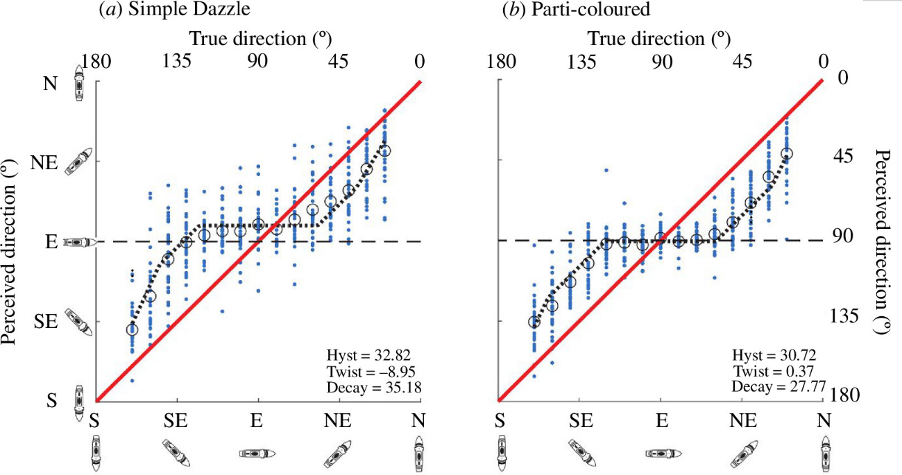style of graph may be more appropriate.

Figure 2. The good graph taken from Lovell et al, 2024

            The second graph, see Figure 2, is the good graph and is from a recent study by Lovell et al. in 2024 that tried to replicate Blodgett's 1919 study. However, due to the errors and missing information, the original study could not be replicated easily, but an adapted version was completed more systematically. One thing that makes Figure 2 a good graph beyond having the axis titles is that it provides measures of the ship's direction not only in degrees but also in direction (e.g. north, east, southeast) and as picture representations of how the ship was oriented. These multiple measures indicate the same thing and increase the accessibility of the graph, as some measures might allow observers of different backgrounds to engage with the graph more easily. Unlike in Figure 1, the different dazzle patterns/colours are located on a separate plot in a grid formation. This layout lends itself to the updates made in the 2024 study as it allows for detailed plots about the ship at different angles while still allowing for comparisons between the patterned ships. The graph also has individual data points (blue dots) along with the average (large black circle) to show the center and spread of the distribution. The red line indicates the ship's actual position, enabling observers to see how the participants' perceptions varied from the actual ship's direction. However, this red line (actual direction of the ship) and the black dotted line (model of data) are not labelled directly but are described in the figure description below the graph. The addition of these labels on the graph may have caused it to become overly cluttered and then unpleasant to look at; it was more appropriate to label them below despite the additional effort that would cause the observer.

In the example I showed, the older graph is worse than the modern graph. This assessment is not because the bad graph is older; rather, it is bad because the experiment it came from was poor in general, and so was the graph. The modern graph follows the correct graph conventions and expresses the data in such a way it is able to connect with many people. As both graphs cover the same topic, I thought it would also be interesting to see how the process of making graphs and plots has changed after the introduction of computer-generated graphics.

References

Blodgett, L. S. (1919).*Ship Camouflage.* [Thesis, Massachusetts Institute of Technology]. http://dspace.mit.edu/handle/1721.1/7582

Lovell, P. G., Sharman, R. J., & Meese, T. S. (2024). Dazzle camouflage: benefits and problems revealed. *Royal Society Open Science*, *11*(12), 240624-. https://doi.org/10.1098/rsos.240624

Meese, T., & Strong, S. (2024, August 25 -29). Bedazzled by dazzle camouflage? *A new experiment, and critical reappraisal of a 105-year-old data set* [Conference presentation]. ECVP 2024, Aberdeen, United Kingdom.